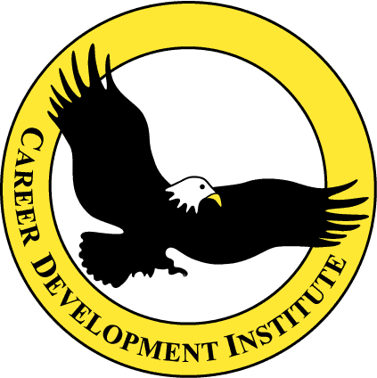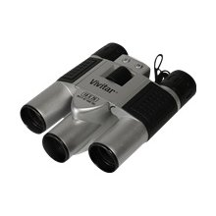

Contact: Career Development Institute FOR IMMEDIATE RELEASE
Telephone: 732-821-6997
Website: www.cditraining.org

Kendall Park, NJ-February 4, 2012- One of the fastest growing service businesses in today’s developing economy is the field of private investigation.

Private Investigators are needed and employed by all types of individuals, companies, and corporations. Private detectives and investigators offer many services, including executive, corporate, and celebrity protection; pre-employment verification; and individual background profiling. Some investigate computer crimes, such as identity theft, harassing e-mails, and illegal downloading of copyrighted material. They also provide assistance in criminal and civil liability cases, insurance claims and fraud cases, child custody and protection cases, missing-persons cases, and premarital screening. They are sometimes hired to investigate individuals to prove or disprove infidelity.

Ocean County College is offering the first Private Investigator Course taught in the State of New Jersey. This exciting new course is ideal for all individuals wishing to pursue careers as Private Investigators. Taught by subject matter experts, topics include skip tracing, legal requirements pertaining to private investigators, the latest surveillance equipment and techniques, courtroom testimony, legal issues, evidence collection, and investigative techniques. One of the highlights of the course is a simulated investigation utilizing the techniques taught during the lectures.

Individuals who are interested in this work as well as presently licensed private investigators/detectives should attend this course. Former police officers and presently licensed private investigators will expand their knowledge and master the most current skills through this course.

Any qualified citizen can be licensed, providing they complete the application designed by New Jersey State Police and meet the legal requirements contained in NJAC 15:55-1.1 relating to personal background and moral character. The applicant for a license must have 5 years’ experience as either a police officer or in conducting investigations. No active law enforcement officer may be licensed. Completion of this course does not guarantee a license. Licensing is at the discretion of the New Jersey State Police, but this course may be a positive factor in the license application process.

The five-day course will be held at the Ocean County College, College Drive, Toms River, NJ. Classes will be held from 9:00 am to 5:00 pm each day. The dress code for this class is business casual. Completion of the course requires attendance at all classes. Tuition for this program is $489, which includes all materials. The class schedule and instructor bios can be found at: www.cditraining.org

If you would like more information contact Career Development Institute at 732-821-6997. To register, contact Ocean County College at 732-255-0400.

